Add MedCommons logo or letterhead

??? Date

Food and Drug Administration
Center for Devices and Radiological Health
510(k) Document Mail Center (HFZ-401)
9200 Corporate Boulevard,
Rockville, Maryland 20850

RE: ABBREVIATED 510(k) for MedCommons™ Connector

Dear Sir:

MedCommons, Inc. intends to market the Connector, a medical image viewer.
The enclosed material is submitted consistent with:
- 21 CFR 807
- FDA’s guidance, How to Prepare an Abbreviated 510(k)’s, and
- FDA’s Guidance for the Submission of Premarket Notifications for Medical Image Management Devices

If there are questions about this submittal, please contact Adrian Gropper, MD, the Chief Medical Officer:

Adrian Gropper, MD
MedCommons, Inc.
52 Marshall Street
Watertown, MA 02472

Email: agropper@medcommons.org
Phone: 617- 571-3857
Fax: 617-nnn-nnnn

Respectfully yours,

Bill Donner
President

Enclosure:
Two copies of the Abbreviated 510(k) for MedCommons™ Connector

MedCommons™ Connector 510(k)

Topic | Page
Cover Letter | 1
Name, title and phone number of contact | 1
Abbreviated 510(k) cover sheet
Table of Contents | 2
510(k) Summary | 3
Name and address of manufacturer
Establishment registration number
Trade name and common name of device
Classification of the device
Intended Use –
Substantially Equivalent (predicate) device
Applicable standards
I. Indications for Use Statement | 2
II. Declarations of Conformity
DICOM Conformance Statement SD to supply
JPEG Standard – Probably – SD to supply
SMPTE Standard???
III. Device Description | 3
Summary of functions | 3
Major components (architecture) | 4
Technical characteristics and principles of operation | 5
IV. Comparison to Predicate Device | 7
Manufacturer and trade name of predicate device | 7
Promotional material and specifications | 7
Tabular comparison | 13
Discussion of similarities and differences | 13
V. Labeling { AB and SB- this will not be available until mid-May }
Promotional material
Users Manual
Prescription device statement
Indications for uses and contraindications
Cautions and warnings
Product specifications
Operating instructions
Image labeling
VI. Software { CB to provide more guidance }
Functions | 14
Software development methods | 14
Hazard analysis | 14
Software test procedures | 14
Certification that software information is correct and will be used | 14
VI. Truthful and Accurate Statement

I. 510(k) Summary for the MedCommons™ Connector
This 510(k) summary of safety and effectiveness information complies with 21 CFR 807.92.

I.A Submittal information:
Manufacturer:
MedCommons, Inc.
54 Marshall Street
Watertown, MA 02472
Establishment Registration pending

Contact person:
??? Adrian Gropper, MD
MedCommons, Inc.
54 Marshall Street
Watertown, MA 02472

(617) 571-3857

??? Date of preparation

I.B Device name and classification
Proprietary Name: MedCommons™ Connector
Classification Name: Picture Archiving and Communications System
Classification Panel: Radiology
CFR Section: 21 CFR 892.2050
Class: II
Product Code: LLZ

I.C Substantial Equivalence
The MedCommons™ Connector is substantially equivalent to the eFilm Workstation, which was cleared in 510(k)’s K020995 and K012211.

I.D. Device Description
The MedCommons™ Connector is a medical image viewer used with the MedCommons™ system name, which among other functions is a medical image storage and communications device. The system stores patient medical information and provides it over the internet to users authorized by the patient. The MedCommons™ Connector is a software application that is downloaded to the user’s computer and allows the user to view image files on the user’s computer display. Image files in DICOM or JPEG format may be viewed.

I.E. Intended Use
The MedCommons™ Connector is designed for use by healthcare professionals viewing medical images stored on the MedCommons™ system name.

I.F. Comparison with the Predicate Device

 | MedCommons™ Connector | eFilm Workstation
Imaging modes
Intended use

I - Indications for Use Statement

510(K) Number __________________

Device Name: MedCommons™ Connector

Indications for Use:

MedCommons™ Connector is a software application that is used for viewing medical images. MedCommons Connector receives digital images and data from various sources (including but not limited to CT, MR, US, RF units, computed and direct radiographic devices, scanners, imaging gateways and image processing sources). Images are stored, communicated, processed and displayed on the local disk of a workstation and/or across computer networks at distributed locations. Tasks that users may perform when viewing images include, but are not limited to: adjustment of window width and level; image stacking; annotation and measurement of regions of interest; and inversion, rotation, and flips of images. In addition, MedCommons Connector can be integrated with an institution’s existing HIS or RIS for automatic linkage or transfer into an electronic patient record.

Typical users of MedCommons Connector are trained medical professionals, including but not limited to radiologists, clinicians, technologists, and others.

III. Device Description

MedCommons Connector is one of the components of a PACS (Picture Archiving and Communications System). MedCommons Connector is a software application that provides image viewing and manipulation in a diagnostic imaging setting. The functions of this application are applied to medical images that acquired and stored on an image server in DICOM and/or other proprietary formats. MedCommons Connector can also transfer DICOM 3.0 images over a medical imaging network, as well as export images to applications in JPEG and/or proprietary formats.

Summary of Functions

- Import and export of medical imaging studies from modalities, PACS and workstations
- Selection, grouping, and editing of medical imaging study contents
- Viewing of medical images for both review and diagnostic indications
- Annotation and characterization of images and imaging studies for clinical referral
- Communication of medical imaging studies
- Storage of medical imaging studies
- Tracking and status display of referral activities
- Authentication and authorization of users and enforcement of security policies

Technological Characteristics

Both the MedCommons Connector and the eFilm™ Workstation are stand-alone software packages which can be used on more than one hardware platform. As long as minimum hardware requirements are met, the user is free to choose their own hardware platform. It is the user’s responsibility to choose image display hardware that is of adequate quality and properly calibrated for the specific clinical application and protocol.

Both systems allow digital image processing and measurement capability. Both systems can transmit to remote viewing stations over a medical imaging network.

MedCommons Connector does not contact the patient, nor does it control any life-sustaining devices. A physician providing ample opportunity for competent human intervention interprets images and information being displayed.
Figure 1- Major Components and Architecture

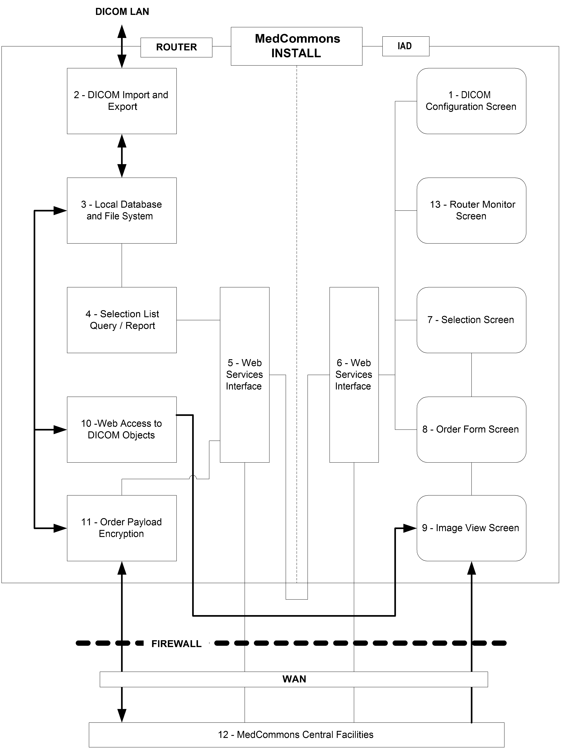
Technical Characteristics and Principles of Operation

Numbers refer to Figure 1 – Major Components and Architecture

The pre-requisite is a computer on the institutional DICOM LAN under the control of a User that has DICOM PACS access privileges. For example, the user would be allowed by the institution to install and operate an eFILM Workstation.

Upon satisfactory Registration with the MedCommons Central Facilities [12] the User is allowed to download a MedCommons Installer to their computer. The Installer installs two distinct components – the Router and the IAD on the computer. In alternate hardware configurations, the Router is installed on a separate computer, the IAD is replaced by a Web browser or the User orders a MedCommons Tablet with software installed.

1 – A DICOM Configuration Screen [1] configures the Router to join the DICOM network.
2 – DICOM Query, Move, etc… to the DICOM Engine [2] are used to populate and update a Local Database [3] of imaging studies in accordance to the user’s privileges and role relative to the PACS.
3 – The Local Database and File System [3] provides temporary storage of imaging studies and items such as pending Orders that might be the subject of a transfer.
4 – A Selection List Query [4] responds to parameters entered by the User on Selection Screen [7] with a Report that populates a list on Selection Screen [7] with items from Database [3]. Alternative embodiments would build a Selection Report by a Query to the PACS directly.
5 – Web Services Interface [5] and [6] relay messages between the Router and IAD using standard protocols.
6 - The Router can be located on a different computer from the IAD and multiple IAD’s can communicate with multiple Routers.
7 – The User picks one or more items from the Selection Screen [7]. Each item typically represents a DICOM Study.
8 – The item(s) selected populate the payload field of an instance of an Order as displayed on the Order Form Screen [8]. Information such as the Patient’s Name and Referring Physician are derived from the DICOM Study metadata and can be used to populate other fields of the Order Form. Furthermore, the Order Form Screen can use the Web Services Interface [6] to fetch additional information from MedCommons Central [12] by using Patient, Physician and other information such as Procedure that is available in the DICOM metadata.
9 – An Image View Screen [9] is available to the User for quality control purposes during the Order creation process.
10 – A Web Access to DICOM Objects (WADO) [10] module supports the View Screen [9]. Alternative embodiments would have DICOM access to the Router by a Diagnostic or 3D Workstation (e.g.: eFILM, Voxar) or could access images directly from the local Database and File System [3].
11 – Finalization of the Order, as communicated via the Web Services Interface, triggers the Order Payload Encryption [11] to package the payload and Order information for transport over the WAN to the MedCommons Central Facilities [12].
12 – The MedCommons Central Facilities [12] provide temporary buffering and routing for studies on the way to Routers at other facilities.
- Payload elements are typically decrypted and re-encrypted with keys that are specific to the destination Router.
- Payload metadata may be examined to assist in routing if the Order Form itself does not have sufficient information.
- Payload images and reports are made available directly to Web browsers using a WADO module at the Central Facility that uses technology similar to that used in the Router..
- The Central Facility keeps a HIPAA Log of transfers that is accessible to the Patient and to other authorized Users.
- The Central Facility provides long-term archiving.
IV. Comparison to Predicate Device
Manufacturer and Trade Name of Predicate Device
Merge eFilm
1126 South 70th Street
Milwaukee, WI 53214
eFilm Workstation 1.9

Promotional Material and Specifications

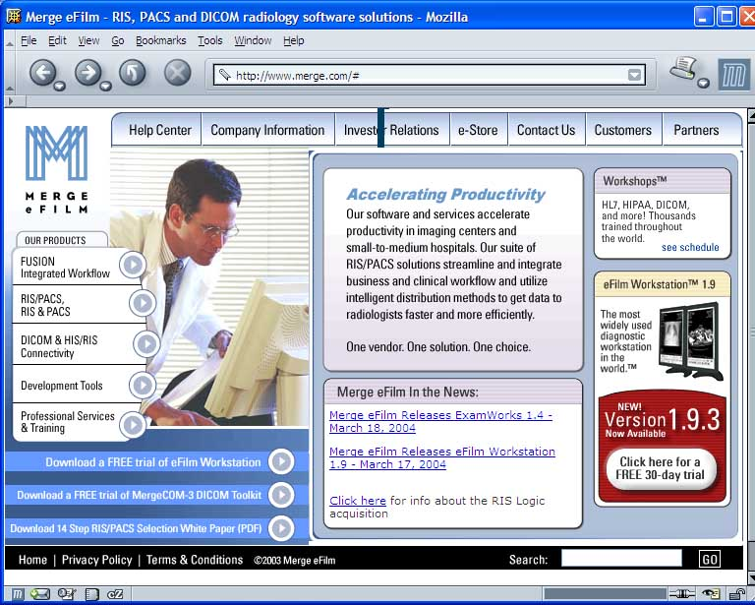

Figure 2 – eFilm Workstation Promotion on Home Page of Manufacturer Web Site
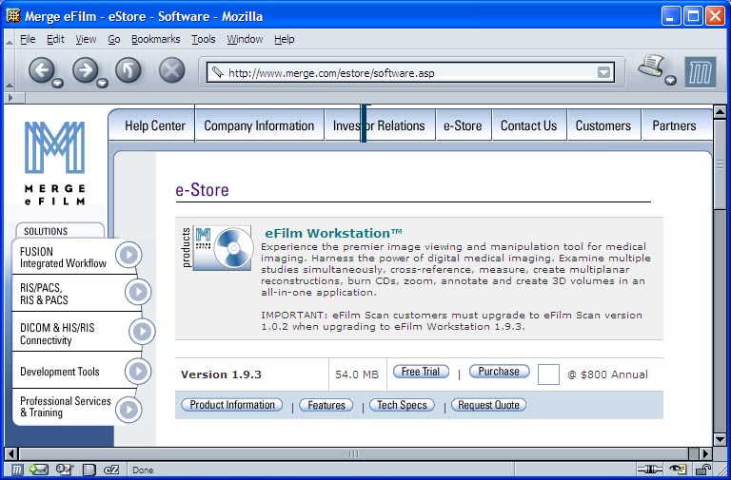

Figure 3 – Promotional Material

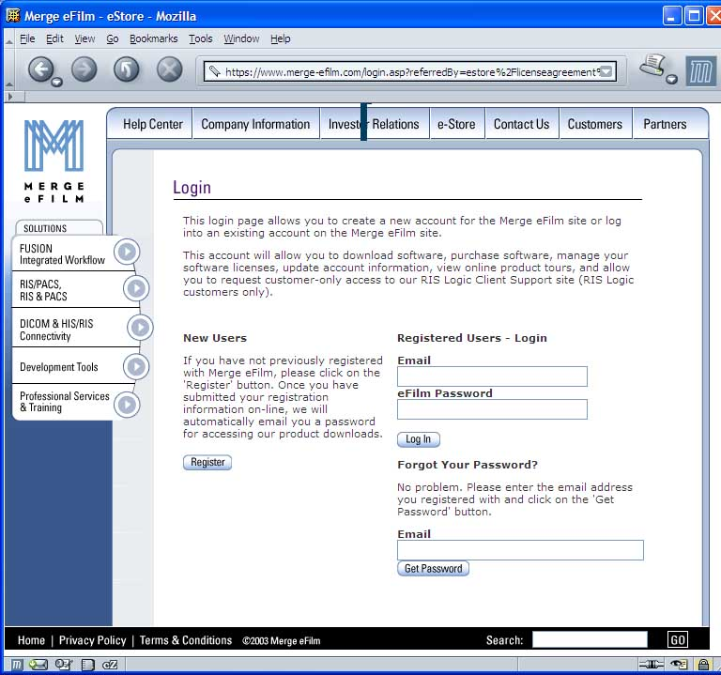

Figure 4 – Registration Invitation

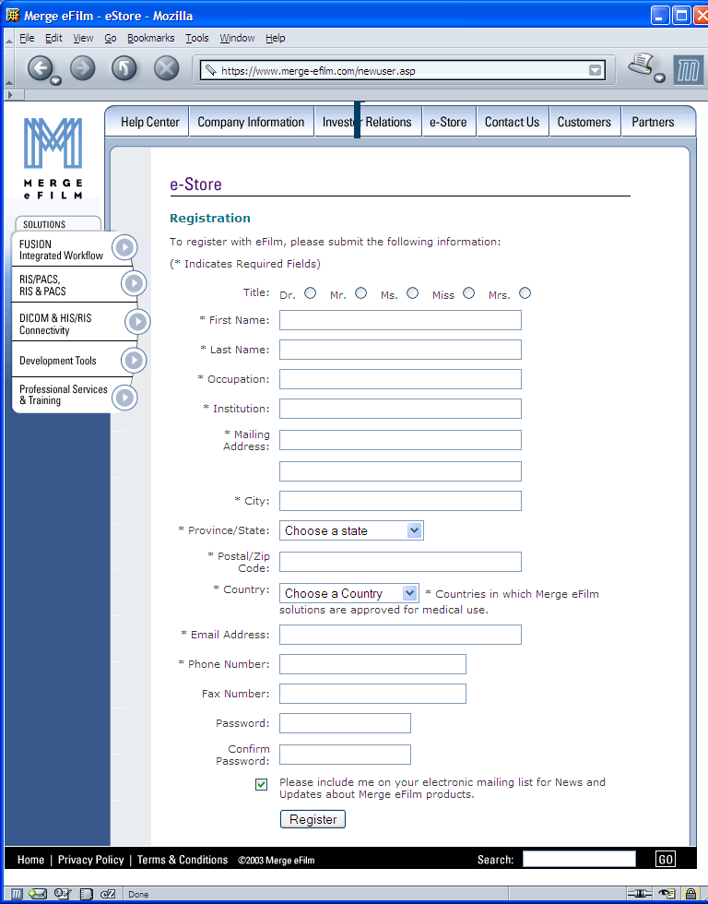

Figure 5 – User Registration

Considerations prior to use
The software is not intended to replace the skill and judgement of a qualified medical practitioner and should only be used by people who have been appropriately trained in the software's functions, capabilities and limitations.
The user should be aware of the limitations in the accuracy and correctness of the output data displayed on the screen, printed, or exported from eFilm Workstation. The quality of the data is dependent on the correctness of the input data, the user's interaction with the data, the quality, characteristics, and settings of the display device or printer, and the necessity to interpolate the data for display purposes. For example, measurement values in eFilm Workstation are dependent on the calibration information provided by the modality in the DICOM header.
While eFilm Workstation has been tested extensively, it is impossible to completely test any piece of software, and errors may remain in the software. It is possible that an error could manifest as an incorrect measurement or image. Users must be aware of the potential for errors.
eFilm Workstation saves images together with patient information, both when saving to the local database and when exporting from eFilm Workstation. It is important to protect this data from access by unauthorized persons.
Users should be aware that certain views make use of interpolated data. This is data that is created by eFilm Workstation based on the original data set. Interpolated data may give the appearance of healthy tissue in situations where pathology that is smaller than the scanning resolution may be present. On occasion, interpolated data may also include image artifacts which should not be interpreted as real pathology.
The image scrapbook function is intended to preserve annotations on images. Scrapbooked images should not be used for primary diagnosis.
Figure 6 – eFilm Workstation User Guide: Cautionary Labeling

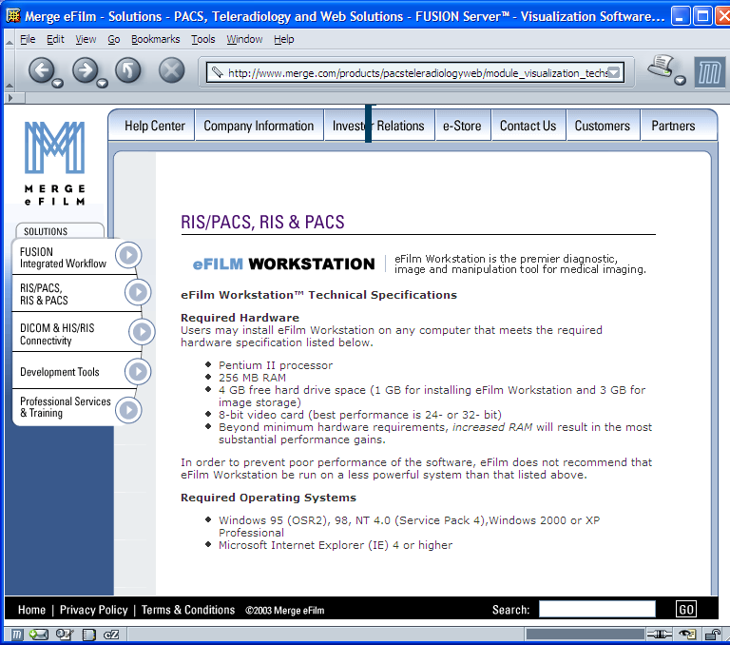

Figure 7 – eFilm Workstation Specifications
Tabular Comparison

Category | eFilm Workstation | MedCommons Connector
PACS Functionality | Yes | Yes
Diagnostic Image Display | Yes | Yes
Image Manipulation and Annotation | Yes | Yes
Image Interpolation and Processing | Yes | Yes
Software Only | Yes | Yes
Install from the Web | Yes | Yes
Documentation Online | Yes | Yes
Centralized Management | Optional | Optional
Software Source Code Online | No | Yes

Discussion of Similarities and Differences

The MedCommons Connector is similar to the predicate device in all respects including function, labeling and intended use. The principal difference between the two devices is in production and quality management procedures due to the extensive use of Open Source Software in the MedCommons Connector device.
MedCommons expects that availability of source code will enable peer review that will improve quality, safety and effectiveness of the MedCommons Connector more effectively as compared to the predicate device and other complex medical devices that enforce secrecy of important and increasingly risky software components.

VI. Software

Functions
{ CB to provide more guidance}

Software Development Methods
- Document and Version Control System
- Bug and Incident Tracking System
- Management Dashboards
- Externally Developed Source Code
  - Treated as Design Input in the Design Control Process
  - Analyzed through an automated tool (TogetherJ, Borland, Inc.)
  - Integrated into the CAPA Process
  - Open Publication of Bugs and Bug Fixes

Hazard Analysis
- Risk Analysis is Central to the Design Control Process

Software Test Procedures
- Software Release Integrity
  - Automated Build and Test
  - Segregated Development, Test and Distribution Servers
- Labeling
  - Product Labeling
  - Image Labeling Validation
- Image Manipulations
  - Image Quality
  - Measurement Accuracy
- Study Integrity
  - Tracking and Logging of Edits and Transformations

Certification that Software Information is Correct and Will Be Used
{ CB to provide more guidance}

